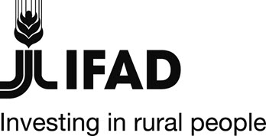 |  | 
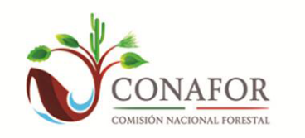

MEXICO

GRANT – MEXICO - FSP-028-MX, GEF ID: 4149

“Mitigation of Climate Change through Sustainable Forest Management and Capacity - Building in the Southern States of Mexico (Campeche, Chiapas, and Oaxaca)", DECOFOS-GEF.

GEF Terminal Evaluation Report Summary

Map of project areas

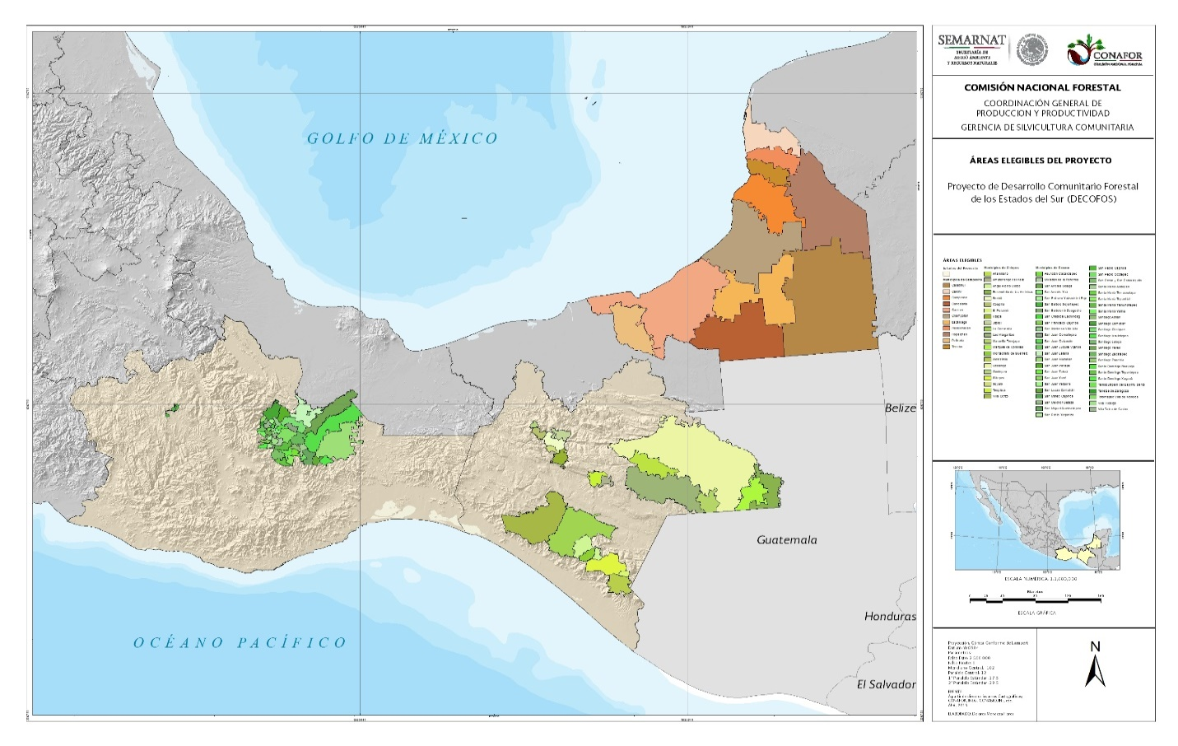

DECOFOS-GEF at a glance

Country | Mexico
Project Name | “Mitigation of Climate Change through Sustainable Forest Management and Capacity - Building in the Southern States of Mexico (Campeche, Chiapas, and Oaxaca)", DECOFOS-GEF
Key Dates
IFAD Approval | Signing | Effectiveness | Mid-Term Review | Original Completion | Actual Completion
 | 15-09-2009 | 27-03-2011 | 15-11-2014 | June - 2016 | 30-09-2016
Original Grant Closing | Actual Grant Closing
31 March 2016 | 30 Sept. 2016
GEF/IFAD Financing
Grant | US$ million | 10.1 | % disbursed | 91%
Actual Costs and Financing (USD ‘000)
Component | GEF | IFAD Co-financing | Beneficiaries | GOVT | Total
1. Capacity building for local management and climate change | 731,626 | 1,225,601 | 156,189 | 7,035,313 | 9,148,729
2. Development of productive projects and climate change | 3,766,273 | 2,861,966 | 621,613 | - | 7,249,852
3. Institutional strengthening | - | 446,500 | 777,801 | 84,463 | 1,309,084
Number of beneficiaries
Total | Direct | Indirect | Women | Men | Youth
nda | nda | nda | nda | nda | nda
Remarks: DECOFOS aimed at benefiting 18,000 households dependent on forest resources (70% ejidatarios and comuneros, 30% population without agricultural rights, of which 25% are women). It aimed at strengthening the capacity of indigenous peoples, i.e., 76% of the project´s target population. DECOFOS-GEF focused initially on 25 of communities of ca. 680,000 people (50.3% are women), of which 83.4% are indigenous peoples, with particular emphasis on the population living in poverty and extreme poverty. However, the impact of the results and outputs of the project on the direct beneficiaries was not recorded: in particular, the number of beneficiaries belonging to the indigenous population, their level of deprivation, gender, and age. There is no record on whether the project's workshops/courses generated changes or not since the performed monitoring only involved payments and amounts made. Therefore, no reliable data allow the analysis of the scope of the project regarding real numbers of beneficiaries.
Project Objective
To mitigate climate change in the agricultural units selected in three Southern States (Campeche, Chiapas, and Oaxaca), strengthening the SFM and creating local capacities, including the reduction of emissions by deforestation and the increase of carbon sequestration potential through the financing of innovative and relevant initiatives for the most vulnerable population, particularly the indigenous peoples, the dissemination of information and local participation in carbon sequestration monitoring.
Country Partners
Executing Agency | National Forestry Commission (CONAFOR)
Government Institutions | Nacional Financiera (NAFIN)
NGOs/CS | Ejidos and forestry communities
Other

Project overview
- Background of IFAD project: Addressing the priorities to develop the forestry value chain presented by the Mesoamerica Project in Mexico, the Government of Mexico (GoM) and the International Fund for Agricultural Development (IFAD) prepared a proposal on social forestry development in 2007 and 2008, to be managed by the National Forestry Commission (CONAFOR), responsible for Mexico’s forest policy. As a result, the “Community-based Forestry Development Project in the Southern States of Campeche, Chiapas, and Oaxaca,” known as DECOFOS, was approved by the IFAD Board of Directors on 15 September 2009 and entered into force on 23 March 2011.
- Rationale for the additional support requested from the Global Environment Facility (GEF): The GoM proposed to complement DECOFOS with GEF resources to carry out GHG/CO₂ emission reduction activities that have other benefits (environmental, economic, social and institutional). This initiative was based on Mexico's strategy for mitigation and adaptation to climate change (CC) to increase CO₂ sequestration and reduce greenhouse gas (GHG) emissions. Combining DECOFOS characteristics regarding the implementation area and target population, this additional GEF project would link two aspects: 1) global agreements on climate change and 2) actions at the local level that incorporate the participation of the more vulnerable population, owner of forest resources.
- Approval of the GEF Supplementary Project: The GEF Council approved in March 2010 the preparation of the project "Mitigation of Climate Change through Sustainable Forest Management and Capacity-Building in the Southern States of Mexico (Campeche, Chiapas, and Oaxaca)," henceforth DECOFOS-GEF, with funding of US$5M to complement the IFAD loan, and national co-financing. Approved in October 2011 and entered into force in January 2012, the project start-up was delayed due to the transition to a new government, in particular to a new regime and its politics that caused the delay in the claim of the GEF funds. Under the coordination of IFAD, CONAFOR jointly executed DECOFOS and DECOFOS-GEF in the states of Campeche, Chiapas, and Oaxaca through the IFAD financing agreement 790-MX and the GEF grant agreement GEF-FSP-028-MX.

GEF/IFAD Goal and objectives
- Goal. Contribute to the improvement of the living conditions of poor and extremely poor people living in forest areas of the States of Campeche, Chiapas, and Oaxaca, through the development of sustainable, and sound productive activities. It would also help to improve CONAFOR’s expenditure, efficiency and effectiveness, facilitating access of beneficiaries to public resources.

- Objective. The specific objectives of DECOFOS (and *GEF grant, in bold) were: (i) to strengthen organizational, management and planning capacities to promote the participation of beneficiaries in activities on natural resource management and conservation and combating climate change; (ii) to promote the creation of sustainable productive businesses that improve beneficiaries' income and living conditions, and supporting projects to prevent and mitigate the impacts of climate change; iii) support CONAFOR so that its programs reach the most marginalized population and improve its efficiency and impact in the execution of the project; (iv) promote gender mainstreaming in all aspects of the program, v*) Enhance the capacities of the target population, for better access to public resources and greater integration into markets, and to generate local capacities to address climate change impacts, and vi*) forestry projects and initiatives for carbon sequestration, through the creation and strengthening of local capacities, seeking to reduce GHG emissions from deforestation and degradation)

Project relevance
- The project was aligned with the obligations of Mexico to various MEAs, mainly the UNFCCC, the CBD and the UNCCD and with policies and programmes of the GoM. It was also closely aligned with GEF strategies, objectives and eligible activities regarding CC and capacity development, such as the CC Strategic Program 6 (management of LULUCF as a means to protect carbon stocks and reduce GHG emissions) and Strategic Objective 7b of the GEF Focal Area Strategy for CC (reduction in emissions through land use, land-use change and forestry.)
- CONAFOR's policy framework was not related to the specificities of DECOFOS-GEF, especially about the definition of the logical framework and the relevance of its goals, to comply with the established indicators. Also, the absence of both CC and gender specialists during the implementation left a vacuum in the supervision of these aspects of the project. DECOFOS-GEF does not provide any evidence of a robust long-term follow-up mechanism of the support granted by the project, nor a program of market insertion support offering post-operation technical assistance to the beneficiaries, which has an impact on its degree of relevance. Based on the above, DECOFOS-GEF was considered partially adequate to the context of the socio-economic conditions of the target population. Project relevance was rated Moderately Satisfactory (MS).
Project effectiveness
- The project had significant adjustments to its logical framework including its indicators, adding emphasis to the capacity development component. In the documents reviewed, there is insufficient evidence to fully confirm that DECOFOS-GEF had a measurable impact by its objectives, nor that its full financing had a significant impact on either rural poverty alleviation or economic growth, by the objectives set out in the project’s framework. As the aide-mémoire of IFAD missions stated: “DECOFOS-GEF support alone can hardly contribute to the reduction of rural poverty. However, under an adequate design with accompaniment, it could play a complementary role.”
- A closure strategy was established, as per IFAD supervision missions’ recommendations, during the last year of the project to strengthen and develop microenterprises, allocating most of the GEF donor resources for the implementation of this activity. There is no follow-up that can measure the consolidation and long-term sustainability of these activities. Also, the late entry of the GEF contribution intended to meet the objectives of the logical framework left aside the strategies for reducing emissions and the registration methods.
- The project´s budget underwent significant modifications during its lifetime to ensure that the necessary budgetary resources were in place, which resulted in an implementation slowdown.
- According to indicators of the REDD+ Tracking Tool, at CEO Endorsement there were 990.06 MtCO₂eq in the project area. At project closure the amount was 901.36 MtCO₂eq, leading to an 88.7MtCO₂eq decrease, meaning that there was a 9% loss of carbon stock. Nonetheless, this result cannot be attributed to DECOFOS-GEF since its activities focused on capacity development and business plans.
- Examples of adequate markets for some of the products promoted by the Project are linked to business plans, but not to all. Comprehensive tools and successful cases that promote an integral process of strengthening ejidos or communities with productive chains that allow raising dividends to low costs of sale are not reported in the documents reviewed. Evidence shows that, during the implementation, as a result of the shortcomings in the design of the data collection mechanisms used by the project, the number of beneficiaries could be overrepresented or not properly registered. The above-mentioned numbers need to be treated with certain caution since the documents report that there is no consistent and systematized follow-up of the impact of project support on the generation of employment and income in the ejidos, communities and participating groups Project effectiveness is rated as Moderately Unsatisfactory (MU).
Project impacts
- The impact of the joint project was meant to contribute to reducing poverty and marginalization of the population located in forests and promoting good practices for the mitigation of CC. In this regard, DECOFOS reported a decrease in the percentage of the population with an income of less than one dollar per day, which fell from 33.6% in 2010 (baseline) to 4% in 2015, exceeding the 50% reduction set by the Millennium Development Goals (MDGs). The documents reviewed do not demonstrate reliable evidence supporting or confirming this impact as a result of DECOFOS-GEF, and whether this reduction can be awarded or caused by it in the region: as the revised PCR and the RIMS indicate, benefits can also be attributed to other programs such as poverty reduction and interventions from other projects. That is if perceived changes in quality of life are due to a project impact or only perceived because it occurred with other changes from other programs in the region.
- The RIMS famine-reduction data are not measurable. Even though it was expected that the project had a positive impact on the social well-being of the poorest population in that regard, there is no reliable evidence that supports it: the achievement of the indicators for the Project's end (child malnutrition, income and household assets) based on secondary sources, have no reliable reference to the impact of the project and its baseline. The data are even contradictory since the RIMS-2015 reports that: "it was possible to identify that, in the area of influence of the DECOFOS, a large part of the households have experienced a 2d season of famine, an aspect that should not be happen at present." For all the above-mentioned reasons, the real impact of the project could not be ascertained in the absence of an impact evaluation and an appropriate M&E System.
- Gender equity and empowerment. The DECOFOS-GEF design contemplated crosscutting actions that favor the inclusion of women, youth and indigenous people as priority attention groups. However, during the implementation, the IFAD oversight mission reported in 2014 that these intentions were only generic statements with little support in concrete affirmative actions that promote the presence and participation of these groups in the various initiatives promoted by the Project. According to RIMS data, the joint project focused on improving the participation of women through the diffusion of the project programs. However, the demand behaved differently than expected, which impacted on the variation compared to what was programmed.
- The MTR also observed that some projects illustrate the participation of women and have shown their ability to achieve the goals of improving employment and income (producers of silk, honey, wood handicrafts) but it was considered as fragmentary information because it cannot be applied to the entire DECOFOS-GEF intervention in the three states. DECOFOS did not hire a gender specialist nor elaborated a gender-inclusion strategy that could be applied during the project implementation, including the GEF component, or replicated after the project’s end.
- Resilience of households and the community. The PCR stated that the training provided the people, ejidos, communities and associations, with basic elements for the execution of their projects and skills to carry out specific activities, to organize themselves and raise awareness about issues related to climate change. The RIMS states that the project was aimed at training people in the management of natural resources, and implemented actions to disseminate these supports. However, the beneficiaries demand was lower than expected (35%). In spite of this, the PCR mentions that important results were achieved, which resulted in the recovery of degraded areas through the implementation and maintenance of agroforestry systems. However, no statistical evidence was found that confirms this information.
- Structural change: The project focused on empowering the poor and marginalized rural households of the three Southern States. The stakeholders’ final workshop (22 assistants) report that DECOFOS and DECOFOS-GEF contributed to generating employment, improving family income, reduced migration to the United States, and encouraged the participation and appropriation of women. No quantitative data is available to confirm or deny these statements.
Project efficiency
- DECOFOS-GEF identified various business models in agrarian units, agro-industries, and micro-enterprises. Based on the economic results of these models and the project costs, the PCR intended to estimate an Internal Rate of Return of 23.7%, concluding that DECOFOS and DECOFOS-GEF represented a good investment for Mexico. However, this low percentage does not reflect good sustainability regarding investment. It also mentions that it was not possible to estimate the IRR at the project’s end since no records were kept on the financial results of the productive investments supported by DECOFOS-GEF. Nonetheless, the PCR also mentions that, during the monitoring missions, some positive results could be observed concerning increased income of some of the beneficiaries in rural microenterprises, technology transfer projects, agroforestry modules, nurseries and nature tourism projects, such as natural corridors and a harness-gliding attraction.
- The national presidential election in 2012 slowed the pace of both projects’ implementation in general since it affected national and institutional authorities. Also, the 2015 State elections in the three States of the project affected the closure of DECOFOS-GEF. It was also afflicted by the three-year delay entry of the GEF funds and by the exchange rate fluctuations that lead to adjustments, hence modifying the scope of actions and results. Both IFAD and GoM contributions were used to fund both projects’ activities until 2014. As per the monitoring missions aide-mémoires, the delays in achieving the expected objectives, such as the 2013 call for proposals, were because the GEF budget had not been claimed. IFAD's support was critical as, during the monitoring missions, it advised the project to claim the funds and make them effective. The GEF initial outputs were faded away in all its components, but the grant amount remained the same. Project efficiency is rated as Moderately Unsatisfactory (MU).
Sustainability
- Evidence shows that the DECOFOS-GEF design was aligned with CONAFOR's institutional operational mechanism. However, the Project was limited regarding long-term monitoring, considering that the mechanism operated with annual calls for projects for which the beneficiaries had to request support on a yearly basis. Several products and services that the beneficiaries obtained through the project do not have added value yet nor have a follow-up strategy to incorporate them into markets. Some projects stayed in the design phase, and need a follow-up to ensure the continuity of environmentally friendly jobs, so the beneficiaries retain their sources of employment and improve their quality of life.
- Environmental sustainability. The use and conservation of natural resources was promoted through the participation of ejidos and communities, in particular at the end of the project, through the 64 community development plans and community action plans, accompanied by mitigation awareness against the effects of climate change. The population of rural communities in poverty and extreme poverty were encouraged to strengthen their capacities in the management, generation and implementation of projects. Without a proper evaluation system in place, nor registration, it is difficult to affirm that the rural development plans will be self-sustaining after the project ends, nor to what extend the communities are readily able to anticipate and adapt to change through clear decision-making processes, collaboration, and management of resources. Without a thorough follow-up, the likelihood of lasting results is reduced. For all the above, it is classified as: Moderately Likely (ML).
Partner performance
- The DECOFOS budget was supervised by IFAD, both the GEF grant and the Fund loan, providing a timely follow-up. NAFIN was the national entity responsible for processing disbursements to IFAD, as per request of CONAFOR. Resources were transferred from CONAFOR’s financial resources management to state management, based on the expenditure schedules defined annually by the SHCP, which is the focal point of GEF in Mexico. The Project Coordinating Unit (UCP) requested payments to service providers and subsidies transfer to DECOFOS-GEF and IFAD beneficiaries. Adjustments were made both to the budget and to the activities of the project: Evidence shows that 92.24% of the GEF funds were requested for the 2015 budget and 7.76% of the remaining IFAD funds.
- This slowdown entails the underlying cause of the change in the country's political regime and its national development plans at the beginning of the project since the expectation of clear lines of the application at national, state and municipal levels has had an impact on the management and administration of DECOFOS and DECOFOS-GEF.
- DECOFOS-GEF administration experienced several changes and challenges. The GSC, also in charge of an IFAD-funded project called PRODESNOS, initially managed DECOFOS and its GEF component. As per IFADs advice, a Project Coordination Unit (UCP) was created in 2014, with the GSC as Account Deputy. It used at first GSC’s Administration system. From 2012 DECOFOS and DECOFOS-GEF used CONAFOR’s administrative monitoring system (SIGA), for administration follow-up. SIGA is limited to financial monitoring of concepts granted to agrarian groups, with no registration of the individual beneficiary information within an ejido, community, or participatory group. Therefore, some direct beneficiaries could have received more than one support or not being properly registered because of the changes in their community or ejido. By mid-2014, the UCP experienced other administrative issues, changing again after CONAFOR’s internal reorganization of 2015 and, in early 2016, the administration changed again. No evidence was found on a DECOFOS-GEF specific monitoring system or platform, where the progress, results, and management of its products were thoroughly documented to monitor its effects and impacts, in particular for 2015 and 2016.
Good practices and Lessons learned
- DECOFOS-GEF has in part contributed to the strengthening of the capacity of organization of the beneficiaries, integrating the people without rights to the land, traditionally not included in the programs of forest use. DECOFOS-GEF gave continuity to an innovative model of a previous IFAD project in the country to support public policies on the diversification of deforested and degraded areas through field activities such as agroforestry modules. It is considered, as an adverse situation, the lack of a strategy to insert rural business into the market during the life of the project and once it ended.
- Innovative activities were carried out in relation to other supports and programs that CONAFOR currently has, mainly being the implementation of productive projects oriented to CC mitigation such as awareness workshops for mitigation and adaptation to CC; establishment of agroforestry modules and community nurseries, and formulation of 64 business plans out of 200 of the original goal. The added value of DECOFOS-GEF lies in the catalyzing effect of the emerging processes with incipient cohesion within CONAFOR (e.g., the mainstreaming of CC issues in forest policies.)
- As an area of opportunity, improving Knowledge Management is fundamental: the lack of systematization of experiences and learning jeopardized the execution of DECOFOS-GEF, and the possible elements for its replication in other territories of interest in the country.
Recommendations
- Joint projects:
i) For future GEF co-financed projects with different agencies, it is advisable to start them at the same time to avoid coordination issues. Also, focusing on joint processes while planning and implementing activities will help to identify opportunities for beneficial cooperation among donors. Producing joint products may in some cases be problematic or infeasible due to different core requirements of different agencies. Therefore, effective and efficient communication is necessary to address both the needs and challenges of the joint projects with multiple donors.
ii) Design: It is advisable to start with an initial assessment of what would be needed to trigger change and market development to reduce GHG emissions rather than focusing on results-based contributions to project objectives. The inclusion of criteria defined by multidisciplinary groups, in particular the academic sector, is recommended to use its expertise on mitigation and adaptation to CC, as well as in registration and management techniques in rural communities. Attention to the most vulnerable population implies a custom-made strategy to adequately address cross cutting issues such as gender inclusion, age, and needs of the marginalized population. Also, it is crucial to guarantee the attribution of the results of the project through a reliable M&E system at short, medium and long terms.
iii) Scaling-up: It is recommended to initially develop a pilot project with local actions, considering the aspects and differences of the three pillars of sustainable development (economic, social and environmental), and the physical, climatic and cultural contexts of the place. Based on concrete and successful results at the Municipal and Micro-basin levels, scale up the project to State, and finally to National levels. Adding the academic and non-governmental sectors to the equation is a way to improve the scope, results, measurement, close monitoring of project progress, and the systematic recording of each aspect, thus reducing operational challenges. The experience of STAP is also an advantage that should be taken in projects financed by the GEF.
iv) Efficiency and Sustainability. It is advisable to strengthen the technical follow-up throughout the cycle of production initiatives supported by the project: from its formulation to its installation and operation in the two years following the start-up. Many projects die out in the first two years of operation without adequate follow-up. Their inclusion in productivity chains is a must. It is critical to ensure that the various productive activities comply with sound technical and scientific criteria and elements. They must also demonstrate their sustainability as an essential point in development with social and economic welfare from natural resources, without compromising their future existence, stability, and functionality. If future projects include these four thematic areas satisfactorily, the sustainability of investments and the achievement of the expected impacts will increase.
- In the case of Mexico, the agrarian organizations must be taken into account, since their situation is different from other countries in the sense that agrarian organizations already exist with rules that restrict the use of resources, but are flexible enough for people without land rights to access to them: It is provided for in the country's agrarian law. In addition, projects must be compatible with the interest of groups and facilitate collective action, and:
- Preference must be given to (i) Strengthening of a local and regional platform to create capacity at the regional landscape level; ii) To ensure that the guidelines emerge from grassroots organizations, so that national policies are in accordance with local interests: that is, what requirements the population has, from the Municipal/State/National government, to request it. (iii) Strengthen local capacities, hitherto insufficient, to bring together the 3 orders of government; (iv) Create synergies between existing projects and programs to avoid overlap and conflicts of interest; and v) Start a project only after a customized M&E system is in place.
Project Performance Rating Summary

- Component/criteria | - Rating
- Relevance | - Moderately Satisfactory (MS)
- Effectiveness | - Moderately Unsatisfactory (MU)
- Efficiency | - Moderately Unsatisfactory (MU)
- Sustainability (risks) | - Moderately Likely (ML)
- Monitoring and Evaluation (M&E) System Assessment, M&E Design, Implementation Plan, and Activities Budget plan. | - Unsatisfactory (U)

